Fundamentals of Java

What does a java class contain?
A java class can contain: Variable, Method, Constructor, Static blocks, non-static block

Variables
- Variable can be defined as a container or placeholder which is mainly used to store data and whatever we store can go and change.
- Based and type of data variable can further be categorized into two data types
- Primitive
- Non-Primitive/Reference

Primitive Data Types
Java support eight primitive data types
- Byte
- Short
- Int
- Long
- Float
- Double
- Char
- Boolean

Observation
- Whenever we need to print message of single or multiple words we then go for pair of double quotes (“”).

- Class Byte1
{
public static void main (String [] args)
{
byte var=10;
System.out.println(Var);
}
}

- Whenever we have to print variable in that doesn’t used pair of double quotes.

Whenever we create any variables, it is required or mandatory that the variable go to through two stages.
- Declaration
- Initialization
- Comments are used in programming to inform developer or automation tester the reason of writing the code.
- Comments are never part of compilation and neither part of execution.
- It is not mandatory that in single line we should perform declaration and initialization the variable but it is also possible to declare variable in one and initialize in next line.

- class Byte2{
public static void main(String[] args) {
byte var1=10; //Declaration and initialization
System.out.println(var1);
byte var2;
var2=20;
System.out.println(var1);
}
}
- class Byte3{
public static void main(String[] args) {
byte var1;//declaration
var1=10;//initialization
var1=20;//Assignment
var1=30; //Assignment
System.out.println(var1);
}
}

- Whatever the value we store in variable that value will get printed
- Variable at any one of point it store only one value.

- class Byte4
{
public static void main(String[] args)
{
byte var1=10, var2=20, var3=30;
System.out.println(var1);
System.out.println(var2);
System.out.println(var3);
}
}
If you have to declare multiple variables of the same time type, we can declare them in single line.

- class Byte5
{
public static void main(String [] args)
{
byte var1=10, var2;
var2=var1;
System.out.println(var2);
}
}
- class byte6{
public static void main(String[] args) {
byte x=10, y=20,temp;
System.out.println(x);
System.out.println(y);
temp=x;
x=y;
y=temp;
System.out.println(x);
System.out.println(y);
}
}

IMP Note: Whenever JVM perform execution or when we create variable it only consumes RAM memory.

- Byte variable in java consumes 1 byte of memory.
1 byte = 8 bits
- In a computer to measure memory we use a standard called as bits. Bytes and so on.
- To store values in one byte of memory for byte variable it is calculate below.
-2^{N} to 2^{N} -1
-2⁷ to 2⁷ -1
-128 to 128 -1
-128 to +127
- class Byte7
{
public static void mmain(String [] args)
{ byte a=27;
System.out.println(a);
byte c=-128;
System.out.println(c);
}
}

Withing single main method we cannot declare multiple variables of same name.
- class Byte8
{
public static void main(String[] args)
{
byte a=100, a=110;
System.out.println(a);
}
}

Short data type
A short variable consumes 2 bytes memory
Short=2 bytes =16 bits
1
1-16 bits
0-15 bits
-2^{n} to 2^{n}-1
-2¹⁵ to 2¹⁵-1
-32768 to 32767
- class short1
{
public static void main(String[] args)
{
short s1=32765;
System.out.println(s1);
}
}

Int Variable
Integer datatype consumes 4 bytes of memory
Int= 4 byte =4*8
=32 bit
1-32
0-31
-2^{n} to 2^{n}-1
-2³¹ to 2³¹-1
-2147483648 to 2147483647

- class int1
{
public static void main(String[] args)
{
int i1=100;
System.out.println("i1"+i1);
}
}

- If have to display a string anything in pair double quotes along with variable then this operation is called concatenation operator.
- In java the concatenation operation is done help of the + operator.

Long datatype
A long datatype consumes 8 bytes of memory
Long = 8 byte =8*8=64bit
1-64
0-63
- class long1
{
}
{
public static void main(String[] args)
{
long i1=1000;
System.out.println("The value of i1: "+i1);
}
}

- Byte , short , int long they all and store integral numbers (whole number )
Ex:10,15,….
- Hence byte, short, int, long they commander integral data types.

Identifier
Identifier Naming Rules
- Name given to a variable, methods, class is called as identifier.
- A valid identifier in java can start with letter. Currency symbols($) and connecting character (-)underscore
Int x=293;
Int $=25;
Int_=9;
s.o.p(x);
s.o.p($);
s.o.p(_);

- An identifier should never start with number.
Int 1=100;
s.o.p(1);

- We can use numbers after letter, or currency symbol ($), connecting character underscore.
Int x1=100;
s.o.p();
int $1=15;
s.o.p();

- An identifier in java does not have any limit but on global standard length should be between 10-15.
- Keywords and reserved words cannot be used as valid identifier name.
Int byte=8;
s.o.p();

Interview Question:
What are total reserved words or keyword supported by java?
53
- Class Name or methods names can be used as valid identifier it is supported by java but not considering as good coding practice.
Int identifier=10;
Int main=33;
s.o.p(identifier);
s.o.p(main);
- We can declare two identifiers in same area but case of the identifier should be not same only then it is possible to declare identifier with same name.
int cyber =10;
int CYBER=5;
s.o.p(cyber);
s.o.p(CYBER);

*Valid identifier can contain following
int Cyber25Succes=10; Valid
int 4Cyber=10; Invalid
int all@cyber=10; Invalid
int cyber_success=10; Valid
int _s =10; Valid
int cyber#=10; Invalid
int int=10; Invalid
int Integer=10; Valid
int 012_3=10; Invalid

- Whenever we assign any to integral datatype the value by default integral.
- To inform the compiler to treat a value not as integer but long type we need to suffix letter.
- Java is by default case sensitive but when its come to value java behave like java is case insensitive.
- class Example1
{
public static void main(String[] args)
{
//byte x=128; int to byte
//short y=32768;//int to short
//int z=12473408934;
long a=212434343;
System.out.println(a);
long b=21474936491;
System.out.println(b);
}
}

Float and Double
Float and double are made to store decimal value.
FLOAT | DOUBLE
- If the decimal accuracy is in the range of 5-6 value we go for float.  - Float can be also defined as single precision.  - Float consumes 4 bytes of memory. | - If the decimal 12-14 accuracy, then we go for double.  - Double can be defined as double precision.  - Double consume 8 byte of memory.

- class Float1
{
public static void main(String[] args)
{
float var1=100.5f; //double to float
System.out.println(var1);
}
}

Whenever we use float decimal value what is need suffix letter f?
If we don’t the suffix letter and by default java will consider decimal value as double type hence ensure the decimal considered as float we have to fix the letter
float var2=200.5f;
S.o.p(var2);

  - Type casting
Typecasting is process of converting one form to another form
It is possible to typecast int to float
It is not possible to typecast float to integer

Char Data Type
- A character data can be represented as a letter. Number or special character enclosed within pair of ‘ ‘ single quotes
Char:
‘a’
Ex:
Char c1//

- A character can accept a single letter or number or special character within pair of single quote
//

C++ as well as java both support character datatype however the character in c++ consumes, 1 byte of memory whereas java character consume 2 bytes why?
In C++ technology primarly it support English language
Every English letter number and special character is given in C++ technology is given unique value called as ASCII value (American Standard code of information interchange)
- As java support not only English language but also support other languages but also support other languages hence java consumes more memory with respect to c++ technology.
- Any letter or number as special character internally java gives unique value called as Unicode value
- Unicode is combination of ASCII value + other language unique values
IMP
- Whenever we assign integer value to character the compiler should generate error but compiler know that integer value and character both are connected or associated with Unicode concept hence it does not throw and error.
- Whenever we assign int to char or char to int internally the compiler will perform auto typecasting.

This print statement will display char c but in integer format (Unicode format)

Boolean datatype
- The Boolean datatype it involves two values True and False.
- This Boolean datatype will consume one bit of memory but is size is not so accurate define.
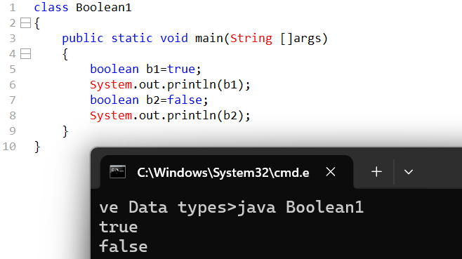

- What is output of following code?

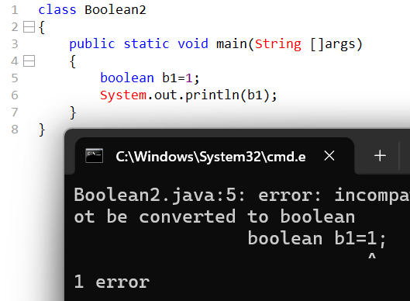
Will Boolean only allow or store data base on particular type hence in java anything apart from true or false will result in error.

Operators
Operators according to precedence or priority.
- Postfix: i++, i--
- Unary: ++I, --I, +I, -i
- Multiplicative: * / %
- Additive: +, -
- Shift: << , >>, >>>
- Relational: <, >, <=, >=
- Equality: ==, !=
- Bitwise AND:
- Bitwise exclusive OR: ^
- Bitwise inclusive OR: |
- Logical AND: &&
- Logical OR: ||
- Ternary: ?, :
- Assignment: -,+-, --, <<=, !=
Multiplication and Addition operator
- class operator1
{
public static void main(String[] args)
{
System.out.println("Hello World!");
}
}

Interview Questions

- What does a java class contain?
A java class can contain: Variable, Method, Constructor, Static blocks, non-static block

- What are the variables?
Variable can be defined as a container or placeholder which is mainly used to store data and whatever we store can go and change.

- Data types
Primitive data types- byte short int long float double char Boolean
Non primitive data types- String Array Object

- What are the comments
- Comments are used in programming to inform developer or automation tester the reason of writing the code.
- Comments are never part of compilation and neither part of execution.

- Which memory does variables consume
Whenever JVM perform execution or when we create variable it only consumes RAM memory.

6. Formula to calculate range of variables
-2^{N} to 2^{N} -1
Range of byte, short
-128 to +127
-32768 to 32767

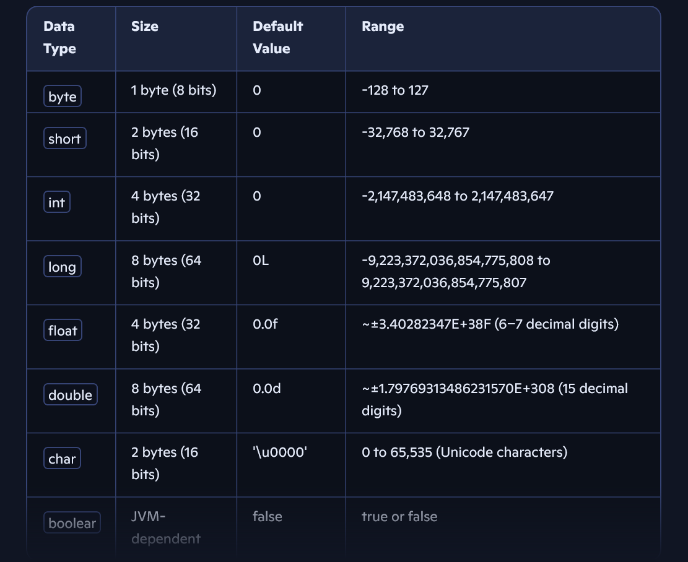

- What are the identifiers
Name given to a variable, methods, class is called as identifier.

- What are the rules to be followed while declaring identifiers
- A valid identifier in java can start with letter. Currency symbols($) and connecting character (-)underscore
- An identifier should never start with number.
- We can use numbers after letter, or currency symbol ($), connecting character underscore.
- An identifier in java does not have any limit but on global standard length should be between 10-15.
- Keywords and reserved words cannot be used as valid identifier name.

9. What are total reserved words or keyword supported by java?
53

- Difference between float and double
Float and double are made to store decimal value.
FLOAT | DOUBLE
- If the decimal accuracy is in the range of 5-6 value we go for float.  - Float can be also defined as single precision.  - Float consumes 4 bytes of memory. | - If the decimal 12-14 accuracy, then we go for double.  - Double can be defined as double precision.  - Double consume 8 byte of memory.

11. Whenever we use float decimal value what is need suffix letter f?
If we don’t the suffix letter and by default java will consider decimal value as double type hence ensure the decimal considered as float we have to fix the letter
- Whenever we assign any to integral datatype the value by default integral.
- To inform the compiler to treat a value not as integer but long type we need to suffix letter.

12. What is typecasting
Typecasting is process of converting one form to another form

13.C++ as well as java both support character datatype however the character in c++ consumes, 1 byte of memory whereas java character consume 2 bytes why?
In C++ technology primarly it support English language
Every English letter number and special character is given in C++ technology is given unique value called as ASCII value (American Standard code of information exchange)
- As java support not only English language but also support other languages but also support other languages hence java consumes more memory with respect to c++ technology.
- Any letter or number as special character internally java gives unique value called as Unicode value
- Unicode is combination of ASCII value + other language unique values

